**IOT BASED UNIVERSITY DEPARTMENT AUTOMATION SYSTEM**

**by**

**151220182077 KEREM NARMAN**

**151220182076 MEHMET AKİF SİNAN**

**151220182073 ÖMER FARUK YILMAZ**

**151220182005 YAVUZ YAYLI**

**A Graduation Project Report**

**Electrical Electronics Engineering Department**

**JUNE 2023**

**IOT BASED UNIVERSITY DEPARTMENT AUTOMATION SYSTEM**

**by**

**151220182077 KEREM NARMAN**

**151220182076 MEHMET AKİF SİNAN**

**151220182073 ÖMER FARUK YILMAZ**

**151220182005 YAVUZ YAYLI**

**A Report Presented in Partial Fulfilment of the Requirements for the Degree Bachelor of Science in Electrical Electronics Engineering**

**ESKISEHIR OSMANGAZI UNIVERSITY**

**JUNE 2023**

**IOT BASED UNIVERSITY DEPARTMENT AUTOMATION SYSTEM**

**by**

**151220182077 KEREM NARMAN**

**151220182076 MEHMET AKİF SİNAN**

**151220182073 ÖMER FARUK YILMAZ**

**151220182005 YAVUZ YAYLI**

**has been approved by**

**Supervisory Committee**

**_________________________________________**

**Prof. Dr. Gökhan Çınar**

**_________________________________________**

**Assoc. Prof. Dr.**

**_________________________________________**

**Asst. Prof. Dr.**

**_________________________________________**

**Prof.Dr. X Y, Chairperson**

# **ABSTRACT**

Lorem ipsum dolor sit amet, consectetur adipiscing elit. Cras ultricies, sapien non euismod malesuada, lorem dolor molestie enim, aliquet suscipit nisi justo ut diam. Integer quis ex eros. Nunc risus quam, luctus vitae egestas non, tempus vitae metus. Aliquam cursus nulla vitae ex suscipit malesuada. Vivamus eu turpis semper, scelerisque tortor et, ullamcorper ex. Morbi cursus, lacus vel tincidunt auctor, eros turpis varius libero, nec consectetur ex dui sed risus. Donec quis risus ex. Mauris laoreet purus vitae velit aliquet, ac malesuada dui pretium. Aenean varius finibus velit, eu imperdiet leo semper sit amet.

Donec sem magna, suscipit non egestas in, suscipit eget erat. Nam ut sapien ac nulla tincidunt tincidunt. Etiam vel efficitur erat. Proin rutrum vel ex id dictum. Mauris quis euismod tellus. Integer gravida congue augue. Sed aliquet ante ligula, sed ultrices dui volutpat ac. Donec et quam sit amet lorem vehicula molestie.

**Keywords:** *mobile robot, autonomous robots*.

# **ÖZET**

Integer accumsan ipsum id libero pellentesque laoreet eu congue elit. Nunc quis aliquam arcu, a lobortis mauris. Integer vitae leo velit. Pellentesque et risus augue. Donec vitae neque vel risus bibendum rutrum. Vivamus porta rhoncus tortor ac egestas. Proin efficitur finibus faucibus. Sed nunc sem, malesuada sit amet sapien sed, efficitur auctor mi. Phasellus blandit arcu sapien, at hendrerit est bibendum sit amet. Cras a enim feugiat, maximus leo at, ornare quam. Nam commodo ex eu enim elementum bibendum. Suspendisse quis purus dui.

Vivamus finibus vestibulum massa, quis scelerisque urna commodo sit amet. Aenean id enim luctus nulla pretium semper vel non neque. Suspendisse nunc sapien, sagittis mollis varius in, tristique quis arcu. Duis quis iaculis ex. Nunc quis sodales risus, sed aliquet sem. Nullam bibendum non neque id venenatis. Vestibulum in velit leo.

**Anahtar Kelimeler:** *mobil robot, otonom robot*.

# **ACKNOWLEDGEMENT**

I would like to thank my supervisor, Prof. Gökhan Çınar for his useful comments and on-going support. I am also very grateful to İbrahim Sadık, for his guidance on the use of SPM and for his comments on several other aspects of the project; and to Ender Korkmaz, for his suggestions regarding the collection of results and useful comments on early drafts of our thesis.

İbrahim Sadık

Electrical Engineer, MSc,

Profession: Power Systems,

Experience: 8 years,

Organization: TCDD … Department, Eskişehir

Ender Korkmaz

Electrical Engineer,

Profession: Communication Systems,

Experience: 2 years,

Organization: EL-KO Engineering Company, Ankara

**TABLE OF CONTENTS**

ABSTRACT iv

ÖZET v

ACKNOWLEDGEMENT vi

LIST OF FIGURES vii

LIST OF TABLES ix

LIST OF SYMBOLS AND ABBREVIATIONS x

1. INTRODUCTION 1

1.1 giriş 1

2. REQUIREMENTS SPECIFICATION 1

3. STANDARDS 2

4. PATENTS 3

5. THEORETICAL BACKGROUND 4

6. METHODOLOGY 4

6.1 System Hardware 4

6.2 Software 5

6.3 Tools 5

7. EXPERIMENTS 6

10. CONCLUSION 9

REFERENCES 9

# **LIST OF FIGURES**

Figure 1: System Diagram 4

Figure 2: Flowchart …. 5

Figure 3: Experimental setup 6

# **LIST OF TABLES**

Table 1: Errors for the different positioning algorithms 6

Table 2: Resource assignments for work packages 7

# **LIST OF SYMBOLS AND ABBREVIATIONS**

**Symbol Explanation**

π: pi number.

α: Phase angle between voltage and current.

TA: Ambient temperature (oC)

**Abbreviation Explanation**

LDR: Light Dependent Resistor.

GA: Genetic Algorithm.

EEE: Electrical and Electronics Engineering.

# **INTRODUCTION**

In this period, when the number of students in universities increased so much, it became difficult to keep the attendance system on paper and to follow it up. Keeping track of students' attendance takes the time of teachers and makes it difficult for students to reach them. The number of attendance/absenteeism of each student is counted by the teacher at the end of the semester and is entered into the information systems at the last stage. Incorrect counts made at this stage can also bring attitudes that will damage the student-teacher relationship. Due to the large class size, the comparison of the signature and the current student cannot be made most of the time, and it occupies a part of the course when it is desired to be done.

In this context, the attendance system also needs to keep up with the developing technology. With the developing technology, IoT (Internet Of Things) systems are spreading and proving itself day by day. An IoT ecosystem consists of web-enabled smart devices that use embedded systems such as processors, sensors, and communications hardware to collect, send, and act on the data they derive from their environments. IoT systems greatly reduce the workload of users and save time. Keeping the data in a created database increases bilateral traceability and enables early detection of possible errors. It consists of web-enabled smart devices using embedded systems such as sensors and communication hardware. IoT systems greatly reduce the workload of users and save time. Keeping the data in a created database increases bilateral traceability and enables early detection of possible errors. It consists of web-enabled smart devices using embedded systems such as sensors and communication hardware. IoT systems greatly reduce the workload of users and save time. Keeping the data in a created database increases bilateral traceability and enables early detection of possible errors.

In this context, we aim to find a solution to this problem through IoT systems by combining modern technologies and user experience. Our aim is to create more environmentally friendly and technological devices by reducing the workload of our teachers while providing students with access to attendance tracking systems. In addition, we are planning to establish a database that can collect and store the data sent by the devices and a website that can open them for user interaction. Through the website we will establish, students will be able to easily track their grades and absenteeism. Sites like these are currently created and run by the ministry at primary and secondary education levels. We aim to create more eye-catching and more functional of these sites.

*Give the motivation and objectives of the project. (Literature overview, existing solutions, etc.)*

*Give information to prove that your engineering design project deals with a complex problem in electrical and electronics engineering.*

*Give the similarities and the differences between your design and the existing solutions.*

# **2. REQUIREMENTS SPECIFICATION**

The designed hardware system will be connected to the internet via the school wi-fi network. Information such as the start time of the lesson, the instructor and the participating students will be stored in the database of the school through this network. The data kept in the database will be used on the website and the absenteeism information of the students will be updated every week.

* **Embedded Software Requirements**

The embedded software will be compiled and loaded with the arduino ide.

The software language of the embedded system will be C++.

* **Web Software requirements**

JavaScript will be used for the Front-End part.

React library will be used for the Front-End part.

Back-end software will be written with Node.js.

* **Physical Requirements**

Total weight of the system cannot exceed 1 kg.

The system will be manufactured in area about 100 cm2.

* **Performance and Functionality Requirements**

The system should read all the student and teacher cards.

When the teacher’s card is read, it will record the starting time of the lesson.

The system will not read the same card twice after starting the lesson.

The data related to the course will be stored in the database after 5 minutes from the course end.

The lesson can end in two ways. The lesson ends after the time is up or the teacher who started the lesson has his/her card read again and ends.

* **Economic Requirements**

The total parts and manufacturing cost cannot exceed $500 per unit.

The total labour cost should be about $2500.

* **Environmental Requirements**

The system will use 20% less energy than the industry average for similar products. The system will serve under temperatures between -10 and 30 celsius degrees.

The system must be waterresist and operate while submersed in water.

* **Health and Safety Requirements**

The system will not expose humans to unhealthy levels of electromagnetic radiation and will meet conditions from safe operation identified in ANSI Std. C95.1.

* **Manufacturability and Maintainability Requirements**

The system will be manufactured on a circuit board with dimensions….

The system will have a modular design such that failed components can be replaced by a technician in under 15 minutes.

Each component will be found easily in the market.

*The requirements should specify what the system will do. The requirement must be verifiable. There must be a way to measure or demonstrate that the requirement is met in the final system realization. The requirements must be stated with a short complete sentence.*

*“A robot must have an average forward speed of 0.5 feet/second, a top speed of at least 1 foot/second, and the ability to accelerate from standstill to the average speed in under 1 second.”*

*Specify the engineering requirements that are relevant with your project. The list of the requirements is given below. Each requirement accompanied by a sample statement.*

*For instance:*

# **3. STANDARDS**

Determine the standards that most likely to impact the design and the requirements. The list below gives some of the types of standards that may be employed in a project and included in the requirements.

* Safety
* Testing
* Reliability
* Communications
* Data Formats
* Documentation
* Design Methods
* Programming Languages
* Connector Standards
* Metastandards

*For instance:*

* **IEC 60228** (*International Electrotechnical Commission's international standard on conductors of insulated cables*.): All cables used in our design have been chosen in accordance with IEC 60228 standards.
* **IEEE 754-2008** (*IEEE Standard for Floating-Point Arithmetic*): Distance values obtained from our sensors have been represented in binary according to double-precision floating-point format as given in IEEE 754-2008 standards.

# **4. PATENTS**

Give the list of the patented designs that have some similarities with your design.

* Autonomus floor-cleaning robot, Patent No: US6883201
* Autonomus coverage robot, Patent No: US8972061

*You can search for patents related to your project by using the following links:*

*Türkiye Patent Enstitüsü*

[*http://www.tpe.gov.tr/TurkPatentEnstitusu/onlinehelp/onlinePatent*](http://www.tpe.gov.tr/TurkPatentEnstitusu/onlinehelp/onlinePatent)

*Google patent search*

[*https://www.google.com.tr/?tbm=pts&gws_rd=cr,ssl&ei=CSxkWOK6DYWKsAHA5KywDQ*](https://www.google.com.tr/?tbm=pts&gws_rd=cr,ssl&ei=CSxkWOK6DYWKsAHA5KywDQ)

# **5. THEORETICAL BACKGROUND**

Formulation of dynamics is calculated from



where $x$ denotes the distance in meters and $y$ denotes….

# **6. METHODOLOGY**

The construction of the project are generally includes two parts: Hardware and software. The software part is also divided into two parts. Front-end and back-end. Things to do at the front-end. The first thing people see when they look at our project is what we call the user interface. The back-end part is a unit that contains a number of functions that generally allow the project to interact. We generally aim to integrate this software into the RFID cards what we will use. In this section, we also aim to combine software and hardware.

*Write some introductory words for section.*

## 

## **6.1 System Hardware**

**Node MCU**

Thanks to the ESP8266 Wifi module on it, it can be easily connected to the Internet, thanks to this feature, it is used a lot in remote control and IOT projects.

**RFID**

RFID belongs to a group of technologies called Automatic Identification and Data Capture (AIDC). AIDC methods automatically identify objects, collect data about them and enter this data directly into computer systems without any intervention. RFID methods use radio waves to achieve this. At a simple level, RFID systems consist of three components: an RFID tag or smart tag, an RFID reader and an antenna. RFID tags contain an integrated circuit and an antenna, which are used to transmit data to an RFID reader (also called an interrogator). The reader then converts the radio waves into a much more useful data format. The information collected from the tags is then transferred via a communication interface to a host computer system, where it can be stored on the data computer and decoded later.

**Figure 1**. System Diagram

## **6.2 Software**

It constitutes a large majority of the project as a percentage. In the automation system we will build, departments, students, staff, internship programs, course schedules, student information, etc. it is the building block that enables the formation of many functions.

**Figure 2.** Flowchart ….

## **6.3 Tools**

* **Node Js**

It is an open-source runtime environment developed for networked applications that usually run on the server side. Node.js applications are developed using JavaScript.

* **Express Js**

Express.js, or Express, Node, published as free and open-source software under the MIT License. It is a backend framework for creating RESTful APIs with js. It is designed for creating web applications and APIs.

* **React Js**

It is an open source JavaScript library that serves to create a user interface. It is being developed by a developer group led by Facebook.

* **Node MCU (ESP8266 V3.)**

Node MCU is an open source, small-sized electronic development board with ESP8266 module on it.

* **RFID (RC 522)**

RFID is an abbreviation used for ”Radio Frequency Identification". It refers to a technology in which digital data encoded in RFID tags or smart labels (smart labels) are received by a reader via radio waves*.*

Give the list of tools that used in the project.

* MATLAB
* Protesus ISIS
* Proteus Ares
* Microsoft Visual Studio
* Texas Instruments CCS 9.0 IDE
* Microsoft Project, etc.

# **7. EXPERIMENTS**

Experiments that are conducted to measure the design requirements. Give the details about experiment set up. You can add some pictures from the experiments. Give the experiment results in a tabular form and add X-Y plot such as time versus temperature, etc.

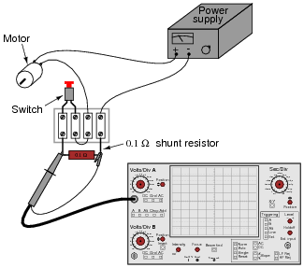

**Figure 3.** Experimental setup

**Table 1**. Errors for the different positioning algorithms

|  |  |
| --- | --- |
| Algorithm | Error (cm) |
|  |  |
|  |  |
|  |  |

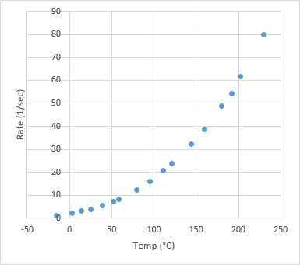

**Figure 4.** Effect of temperature in the rate parameter

**9.PROJECT PLAN**

* **Work Package 1 – Literature Search:** Basic engineering and scientific principles, related technologies and existing solutions are searched.
* **Work Package 2 – Coding:** Control system is coded for PIC16F877 by using microC pro and proteus 8.1.

Table 2: Resource assignments for work packages

|  |  |  |
| --- | --- | --- |
| Work Package | Resource | Duration (weeks) |
| 1 | Ali Veli, Ayşe Fatma | 1 |
| 2 | Ali Veli | 5 |
| 3 | Hasan Hüseyin | 1 |
| 4 | Veli Fuat, Sevgi Dilek | 5 |
| ***PROJECT COMPLETITION TIME*** | | 12 |

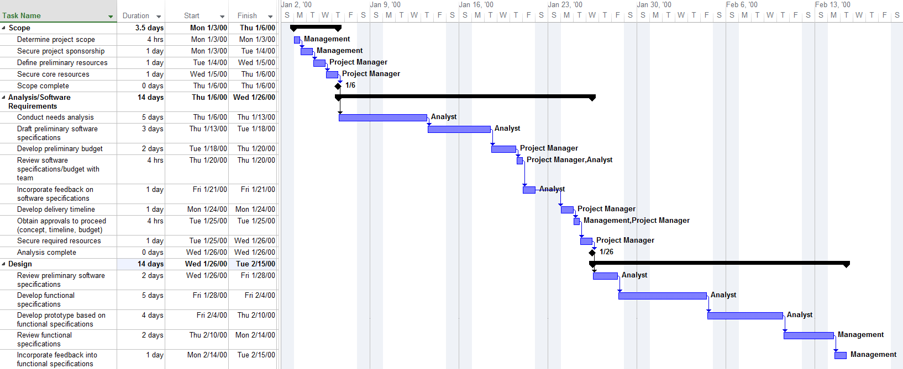

Figure 5: Gantt Diagram of the project.

# **10. CONCLUSION**

Discuss the what you have achieved in your project and possible improvements. Evaluate your design according to the design specifications. Which requirements met by the project? Are there anything that are not accomplished yet? What is your plan to complete the project?

# **REFERENCES**

*The style for references must comply with the IEEE journal format*.

<https://www.ieee.org/documents/style_manual.pdf>

*For instance:*

[1] J. Zhang and N. Tansu, “Optical gain and laser characteristics of InGaN quantum wells on ternary InGaN substrates,” *IEEE Photon. J.*, vol. 5, no. 2, Apr. 2013.

[2] S. Azodolmolky *et al*., Experimental demonstration of an impairment aware network planning and operation tool for transparent/translucent optical networks,” *J. Lightw. Technol*., vol. 29, no. 4, pp. 439–448, Sep. 2011.

[3] B. Klaus and P. Horn, *Robot Vision*. Cambridge, MA, USA: MIT Press, 1986.

[4] M. Abramowitz and I. A. Stegun, Eds., *Handbook of Mathematical Functions* (Applied Mathematics Series 55). Washington, DC, USA: NBS, 1964, pp. 32-33.

[5] *Motorola Semiconductor Data Manual*, Motorola Semiconductor Products Inc., Phoenix, AZ, 1989.

[6] Emarketer.com, 'Social Networking Reaches Nearly One in Four Around the World', 2014. [Online]. Available: http://www.emarketer.com/Article/Social-Networking-Reaches-Nearly-One-Four-Around-World/1009976. [Accessed: 23- Jun- 2014].

…